

Project Initialization and Planning Phase

Date | 8 july 2026
Team ID | SWTID-2026-6237
Project Name | Credit card approval prediction
Maximum Marks | 3 Marks

Define Problem Statements (Customer Problem Statement Template):
Create a problem statement to understand your customer's point of view. The Customer Problem Statement template helps you focus on what matters to create experiences people will love. A well-articulated customer problem statement allows you and your team to find the ideal solution for your customers' challenges. Throughout the process, you’ll also be able to empathize with your customers, which helps you better understand how they perceive your product or service.
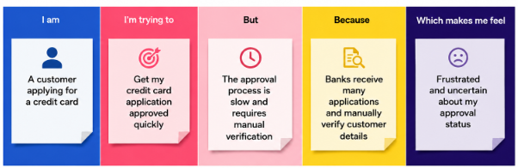

E

Problem Statement (PS) | I am (Customer) | I’m trying to | But | Because | Which makes me feel
PS-1 | A bank officer | Process applications quickly | Reviewing every application manually takes a long time | There are many applications and limited staff. | Overloaded and stressed
PS-2 | A bank manager | Reduce wrong approval decisions | Manual decisions may contain errors | Human judgment can be inconsistent | Concerned about financial risk

